Internship Report

# MERN STACK

**DLithe Consultancy Services Pvt. Ltd.**

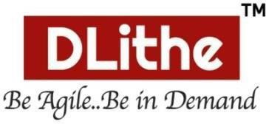

# Internship Report

**Trainee/Intern Name : UDAYA K R**

**Period : 15 Weeks**

**Job Assignment : Virtual learning Platform**

**Organization : DLithe Consultancy Services Pvt. Ltd.**

**Supervisor’sName : Purushottam Pattanashetty**

**Observations :**

* The Virtual Learning Platform simplifies the management of learners, educators, virtual classes, and announcements through a centralized web interface.
* Key modules include User Management (Learner and Educator), Automated Matching, Virtual Class Integration, Announcement Management, and Profile Management.
* The platform facilitates real-time interaction and provides features enhancing the online learning experience.
* The system could be enhanced in the future with automated notifications, more granular user roles and permissions, and deployment to cloud platforms for better scalability..

**Submitted to**

Signature of Training Supervisor Signature of Co-ordinator

Date: Date:

**Letter of Transmittal**

To,

**Program Co-ordinator** DLithe Consultancy Services Bengaluru

Dear Sir,

I submit my report on the development of a **Virtual Learning Platform** using the MERN stack. This project allowed us to apply full-stack web development skills to create a practical and user-centric educational tool.

The development process focused on implementing core features for online learning, including user management, automated matching, virtual class integration, announcement handling, and profile management.

Throughout the project, we aimed to build a responsive and intuitive platform that effectively connects educators and learners, and streamlines the virtual learning experience.

We believe the skills and experience gained will be valuable in our future development roles. This report details the development process and demonstrates the potential of web technologies in creating effective learning solutions.

Sincerely,

Name : Udaya K R.

Interns at DLithe Consultancy Services

# Table of Contents

|  |  |
| --- | --- |
| Introduction | 5 |
| Literature survey | 6-7 |
| Proposed work | 8-9 |
| Implementation | 10-20 |
| Conclusion | 21 |
| References | 22 |

## INTRODUCTION

The landscape of education is rapidly evolving, with online platforms playing an increasingly crucial role in facilitating learning and knowledge sharing. As the demand for flexible and accessible education grows, the need for efficient and user-friendly virtual learning environments becomes paramount. However, managing various aspects of online learning, such as connecting educators and learners, organizing virtual classes, and disseminating information, can become complex without a dedicated system.

In response to these needs, this project introduces a comprehensive Virtual Learning Platform—a web-based system designed to streamline and digitize the core interactions of online education. The platform focuses on automating essential modules including user management for learners and educators, intelligent matching based on learning needs and teaching expertise, integration of virtual class tools, and efficient communication of announcements and updates.

The Virtual Learning Platform is developed using the MERN stack—MongoDB, Express.js, React.js, and Node.js—which provides a robust, scalable, and responsive application architecture. This modern technology stack enables seamless front-end and back-end integration, ensuring a smooth user experience while maintaining high performance and scalability.

Key features include secure user authentication, an intuitive interface for both learners and educators, seamless integration with virtual meeting platforms, and a centralized system for managing announcements and user profiles. The platform aims to enhance the online learning experience by providing a unified and efficient environment for all stakeholders.

This system not only reduces the complexities of managing disparate online learning tools but also enhances operational efficiency and fosters better connectivity between learners and educators. By digitizing these processes, the Virtual Learning Platform empowers educational interactions, facilitates personalized learning experiences, and supports the growth of online education initiatives.

## LITERATURE SURVEY

The increasing demand for accessible, flexible, and engaging online education has spurred the adoption of digital learning platforms. This section reviews existing technologies, frameworks, and practices that have influenced the design and development of virtual learning environments.

**2.1 Digital Transformation in Education**

Digitization is transforming education by replacing traditional methods with centralized, web-based systems. Studies indicate that online learning platforms enhance accessibility, improve learning outcomes, and facilitate collaboration. Tools supporting course management, student interaction, and progress tracking are becoming vital for modern educational institutions and individual learners.

**2.2 Existing Virtual Learning Platforms**

Platforms such as Coursera, edX, and Moodle offer extensive functionalities like course hosting, learning management systems (LMS), and assessment tools. However, these platforms can sometimes have limitations such as complex interfaces, high costs for certain features, and limited customization for specific needs. Individual educators or smaller organizations might find them overwhelming or not perfectly suited for their unique requirements.

**2.3 Use of NoSQL Databases**

The flexibility and scalability of NoSQL databases, particularly MongoDB, make them well-suited for managing the diverse and evolving data associated with learning platforms. In the context of virtual learning, MongoDB allows for efficient storage and retrieval of user profiles, course content, interaction logs, and announcements without rigid schema constraints.

**2.4 Security & Access Management**

Security is paramount when handling user data and educational content. Industry-standard practices such as JWT-based authentication, role-based access control (RBAC) for different user types (learners, educators, administrators), and secure API endpoints are crucial to ensure data privacy and prevent unauthorized access.

**2.5 Front-End Technologies and Accessibility**

User-centered design is key to the successful adoption of online learning tools. Libraries like React.js enable the development of responsive and interactive user interfaces that are accessible across various devices. Features such as clear navigation, intuitive layouts, and role-specific dashboards enhance the user experience for individuals with different levels of technical proficiency.

**2.6 Communication and Real-time Features**

Effective communication and real-time interaction are vital in virtual learning environments. Technologies like WebSockets can facilitate real-time messaging, notifications, and updates, enhancing engagement and fostering a sense of community among learners and educators. Integration with video conferencing tools like Google Meet enables seamless virtual class sessions.

**2.7 Limitations in Existing Systems**

Despite the availability of numerous platforms, many educators and learners face challenges such as a lack of seamless integration between different tools, limited options for customization to specific teaching styles or learning preferences, and the need for simpler, more focused solutions.

**2.8 Future Directions**

Future trends in virtual learning technology may include the integration of AI for personalized learning paths, automated feedback mechanisms, enhanced accessibility features, and more immersive learning experiences through technologies like AR/VR. While these were not the primary focus of the current platform, the modular design allows for potential future expansion.

## PROPOSED WORK

The objective is to design and develop a centralized, modular, and scalable Virtual Learning Platform that addresses the core needs of online education. The platform is built using the MERN stack—MongoDB, Express.js, React.js, and Node.js—to create a modern, full-stack web application capable of efficiently managing users, courses, interactions, and learning resources.

This initiative was undertaken to provide a comprehensive solution for online learning, emphasizing key areas: user management, course delivery, and communication. The proposed system is structured to fulfill these core operational needs through the following interconnected modules:

**3.1 Authentication and Role-Based Access Control**

A robust authentication system using JWT is implemented to distinguish between Learner and Educator roles. Educators have access to course management features, while Learners have access to course content and learning tools, ensuring data security and proper access segregation.

**3.2 User Management Module**

A dedicated module captures Learner and Educator profiles, including name, contact details, learning/teaching preferences, and progress/performance. This data is filterable and manageable by administrators. The system also supports user tracking and activity logging.

**3.3 Course Management System**

Educators can create, update, and manage course content, schedules, and materials. The system supports course categorization, enrollment management, and progress tracking. Learners can access course materials, participate in discussions, and submit assignments.

**3.4 Virtual Class Integration**

The system supports integration with virtual meeting platforms (e.g., Google Meet) for live classes and interactions. Educators can schedule and manage virtual sessions, while Learners can join and participate in real-time.

**3.5 Communication and Notification**

To enhance engagement, the platform provides tools for announcements, messaging, and notifications. These features support better communication between Educators and Learners, as well as organization-wide announcements.

**3.6 Learning Resources and Assessment**

The system features tools for managing learning resources such as documents, videos, and presentations. It also supports assessment features like quizzes, assignments, and grading, allowing Educators to evaluate Learner progress.

**3.7 Admin Dashboard and Reporting**

The admin dashboard includes:

* Analytics on user activity, course enrollment, and platform usage.
* Tools for managing users, courses, and system settings.
* Reporting features for generating statistics and insights.

**3.8 Integration Strategy**

The system uses Axios for API calls, React Context API for state management, and structured RESTful APIs for modular back-end development. This architecture ensures scalability and allows for the integration of third-party services in future iterations, such as learning analytics tools or content management systems.

**3.9 Scalability and Future Scope**

While the current version focuses on core virtual learning functions, the architecture allows for future enhancements such as:

* Personalized learning paths and recommendations
* Integration with learning analytics platforms
* Enhanced support for different content formats
* AI-powered tutoring and feedback

## IMPLEMENTATION

The implementation phase involved translating the project design into a functional, full-stack web application using the MERN stack (MongoDB, Express.js, React.js, and Node.js). The Virtual Learning Platform was built with a focus on modularity, usability, role-based control, and efficient data handling, ensuring it meets the objectives of connecting learners and educators, managing courses, and facilitating online interactions.

### Technology Stack and Tools Used

|  |  |
| --- | --- |
| Category | Tools / Technologies |
| Frontend | React.js, HTML5, CSS3, JavaScript (ES6+) |
| Backend | Node.js, Express.js |
| Database | MongoDB Atlas (cloud-hosted NoSQL database) |
| Authentication | JSON Web Token (JWT), React Context API |
| APIs | RESTful APIs via Express.js |
| Virtual Class | Integration with Google Meet API |
| Development Tools | VS Code, Postman, Notion, Google Sheets |
| Version Control | Git, GitHub |

* 1. **Key Functional Modules and Implementation Details:**

**A. User Roles and Secure Authentication**

JWT-based authentication was implemented to distinguish between Learner and Educator roles. Secure login and protected routes ensure that administrative and educator functionalities are restricted to authorized personnel only.

**B. Responsive Frontend Design**

The frontend, built using React.js, is responsive across devices. The UI includes user-friendly forms, dashboards, course listings, and interactive elements, ensuring a smooth user experience for all users.

**C. User Management**

Administrators can access Learner and Educator profiles with details like name, email, learning/teaching preferences, and activity logs. User registration and profile updates are managed through secure forms.

**D. Course Management Workflow**

Educators can create, view, edit, and delete courses. Course details, including title, description, content modules, and schedules, are stored in MongoDB and managed through the admin and educator interfaces.

**E. Virtual Class Integration**

The platform integrates with the Google Meet API to allow educators to create and manage virtual class links within the platform. Learners can easily access these links to join live sessions.

**F. Announcement System**

Administrators and educators can create and post announcements, which are displayed on relevant dashboards. This ensures efficient communication of important updates and information to users.

**G. Profile Management**

Learners and educators can manage their profiles, update their information, and customize their settings within the platform.

**H. API Integration and State Management**

RESTful APIs were designed for modular data interaction between the client and server. React Context API manages global state such as user authentication and course data, ensuring efficient component rendering and data flow.

**I. Version Control and Collaboration**

Git and GitHub were used throughout the development lifecycle for source control, branching, merging, and issue tracking. This ensured safe collaboration and version history management.

The implementation phase demonstrated practical proficiency in full-stack development and strengthened the understanding of building real-world web applications for educational purposes.

The implementation phase demonstrated practical proficiency in full-stack development and strengthened the understanding of real-world web applications designed for nonprofit use cases.

**Data Flow Diagram (DFD):**

**Sequence diagram:**

**Test Cases :**

|  |  |  |  |
| --- | --- | --- | --- |
| **S.No** | **Test Case ID** | **Description** | **Expected Outcome** |
| 1 | TC01 | Register New Learner | Learner profile is stored and appears in the user list |
| 2 | TC02 | Learner Enrolls in Course | Learner is added to the course roster; course visible on dashboard |
| 3 | TC03 | View Course Content | All modules and materials for the selected course are displayed |
| 4 | TC04 | Register New Educator | Educator profile is stored and appears in the user list |
| 5 | TC05 | Educator Creates New Course | Course is created and visible in the course management section |
| 6 | TC06 | Educator Schedules Virtual Class | Virtual class link is generated and visible to enrolled learners |
| 7 | TC07 | Learner Joins Virtual Class | Learner is redirected to the virtual class via the provided link |
| 8 | TC08 | View Platform Announcements | All active announcements are displayed to the user |
| 9 | TC09 | Unauthorized Access to Admin Panel | Non-admin users see 'Access Denied' message |
| 10 | TC10 | Attempt Login with Invalid Credentials | System displays an error message for incorrect login details |
| 11 | TC11 | View User Profile | User's profile details are displayed correctly |
| 12 | TC12 | Search for Available Courses | Relevant courses matching the search criteria are listed |
| 13 | TC13 | Educator Updates Course Content | Changes to course content are saved and visible to learners |
| 14 | TC14 | Learner Submits Assignment | Assignment is uploaded and marked as submitted for the educator |
| 15 | TC15 | Educator Grades Assignment | Grade is recorded and visible to the learner |

## SnapShots:

### Signup Page

The figure 6.1 indicates the Signup page; here both teacher and student can register.

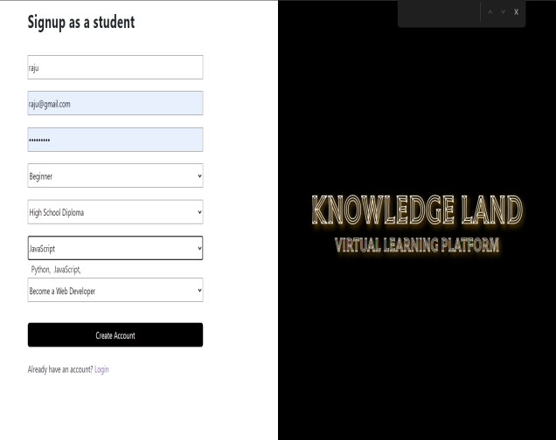

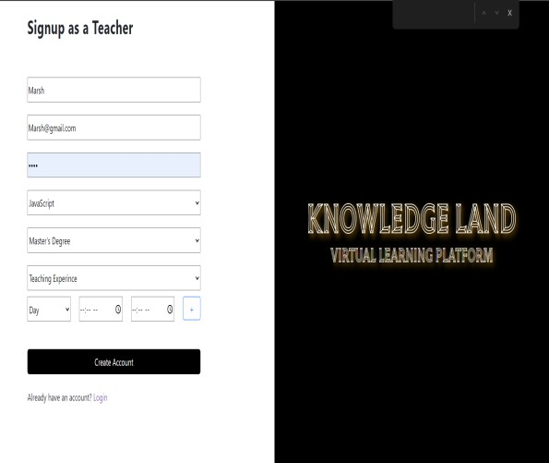

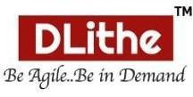

### Login Page

Figure 6.2 indicates the Signup page; here both teacher and student can register.

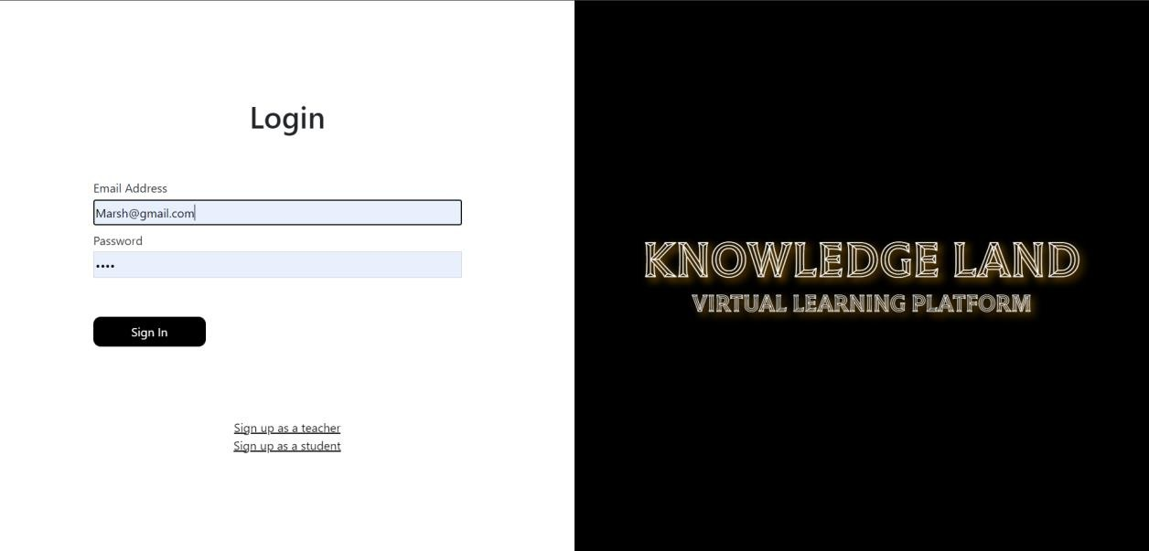



### Course assigned

The figure 6.3 tells about Course assigned to student.it depends upon students and teacher selected courses during registration.

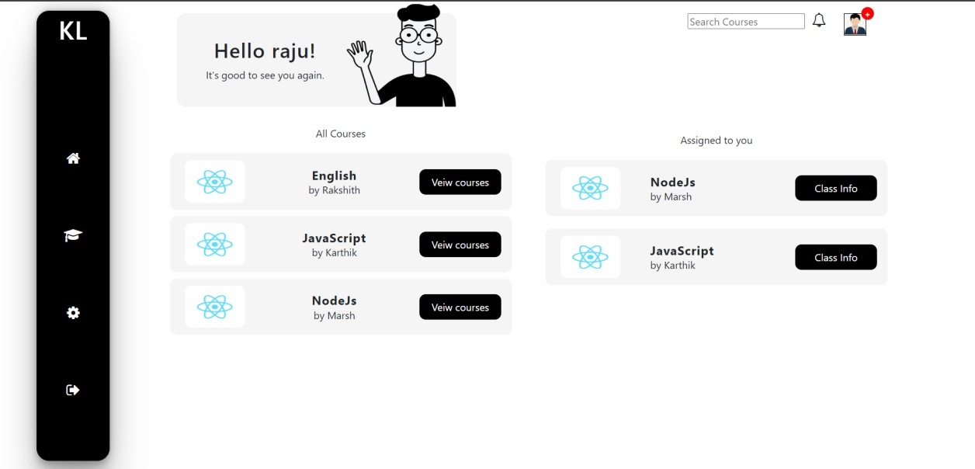



### Change credential

The figure 6.4 tells about the option for changing credential once after signup. Here student and teacher can change their name, email address and password in their respective panel.

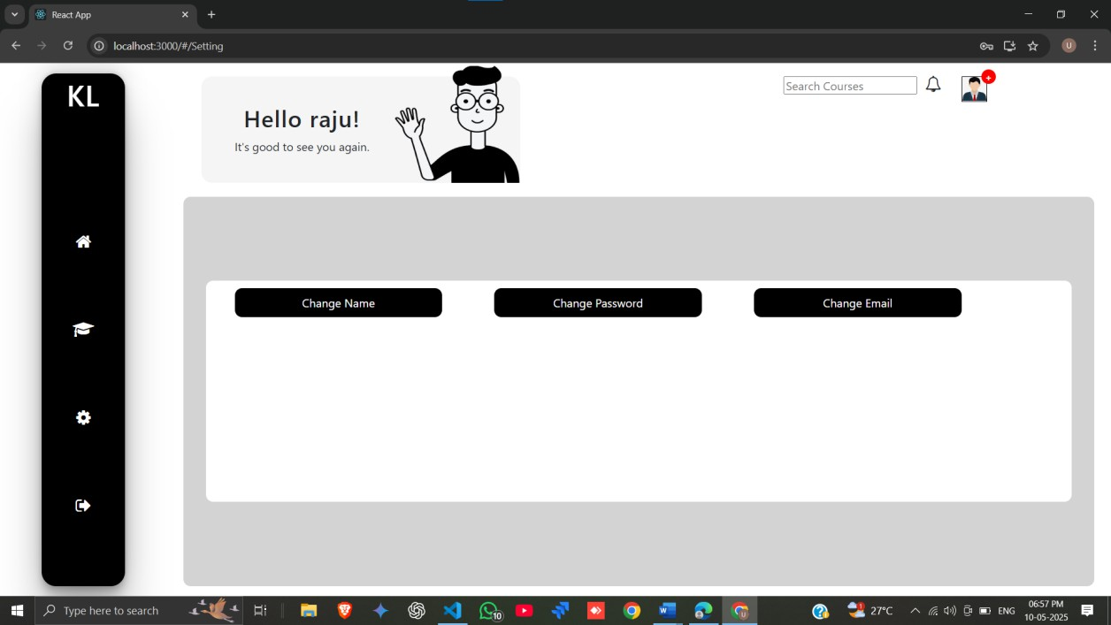



### Class

The figure 6.5 talks about updating class link and joining successfully

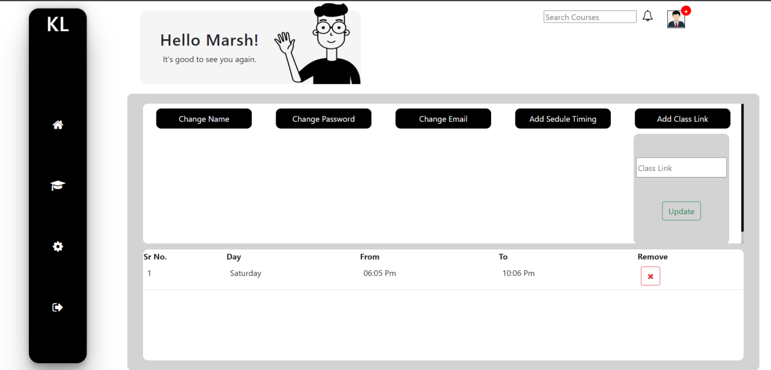

1. **CONCLUSION:**

The development and deployment of the Virtual Learning Platform successfully addressed the core operational needs of online education, particularly in managing users, courses, virtual interactions, and information dissemination. By leveraging the capabilities of the MERN stack, the system delivered a robust, secure, and scalable solution tailored to facilitate effective online learning experiences.

Throughout the project, several technical and functional milestones were achieved:

**Centralized Learning Environment:** The platform integrated user management (learners and educators), course organization, virtual class access, and announcement dissemination into a unified system, reducing the need for multiple disparate tools.

**Time Interaction:** With features such as virtual class integration and announcement systems, the platform enabled real-time interaction and communication between learners and educators.

**Data Accessibility and Management:** User-friendly interfaces for accessing course content, managing profiles, and viewing announcements ensured ease of use for all stakeholders.

**Security and Role Segregation:** Secure JWT-based authentication and distinct user roles for learners and educators guaranteed data privacy and protected administrative functionalities.

**User-Centric Design:** A responsive and intuitive UI, built using React, made the platform accessible across various devices and user skill levels.

The Virtual Learning Platform not only meets the current requirements of online educational workflows but also establishes a foundation for future enhancements. Possible extensions could include:

* Integration with learning analytics tools to track learner progress and engagement.
* Implementation of personalized learning paths and content recommendations.
* Enhanced support for diverse learning materials and assessment methods.

### REFERENCES

1. World Wide Web Consortium (W3C), “HTML Standard” (Latest Version).
2. Mozilla Developer Network (MDN), “CSS Documentation” (Latest Version).
3. React Team, “React Documentation” (Latest Version). [Online]. Available: <https://react.dev/>
4. Node.js Foundation, “Node.js Documentation” (Latest Version). [Online]. Available: <https://nodejs.org/en/docs/>
5. Express.js Team, “Express.js Documentation” (Latest Version). [Online]. Available: <https://expressjs.com/>